***NEWS AND REPORTING***

*USER GUIDE*

| **Supervisor** | Sir Zaman | |
| --- | --- | --- |
| **Batch** | 2207e | |
| **Group** | NEWS AND REPORTING | |
| **Serial No.** | **Enrollment Number** | **Student Name** |
| 1. | 1398351 | Sumaiya |
| 2. | 1398408 | Sanober |

***USER GUIDE***

**“For Every Update**” This Website is basically based on live news updates . If you want to know what’s going on all over the world, so this is the best selection.

**1. Top Layout**

This is the Top of the page.

* User can know about the website by clicking on About Us button
* Users can get touch to the admin by Registering their selves from this page.



**2.** **Home Page**

* This page contains headlines,live updates & also prepares material for people of the different regions of the world.

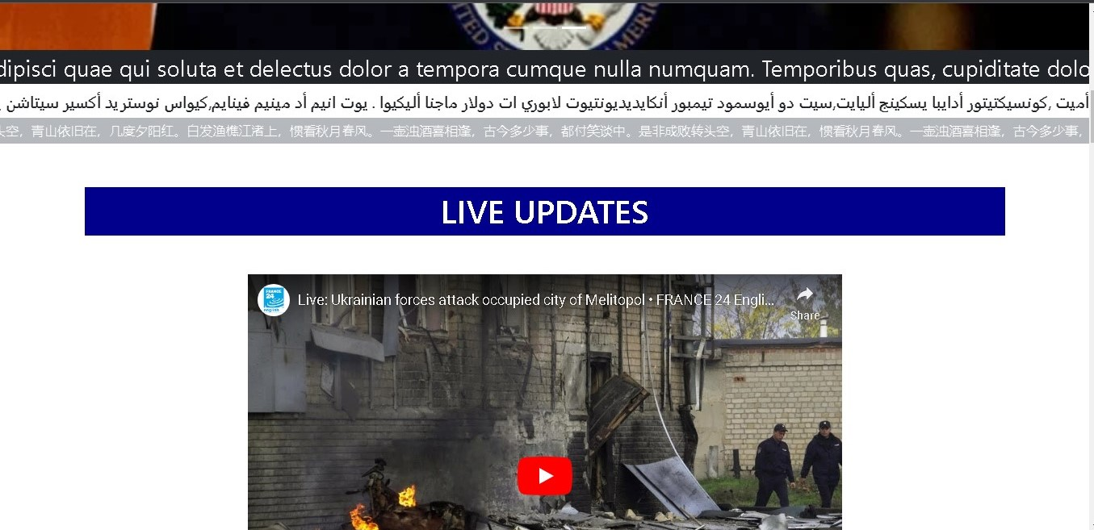

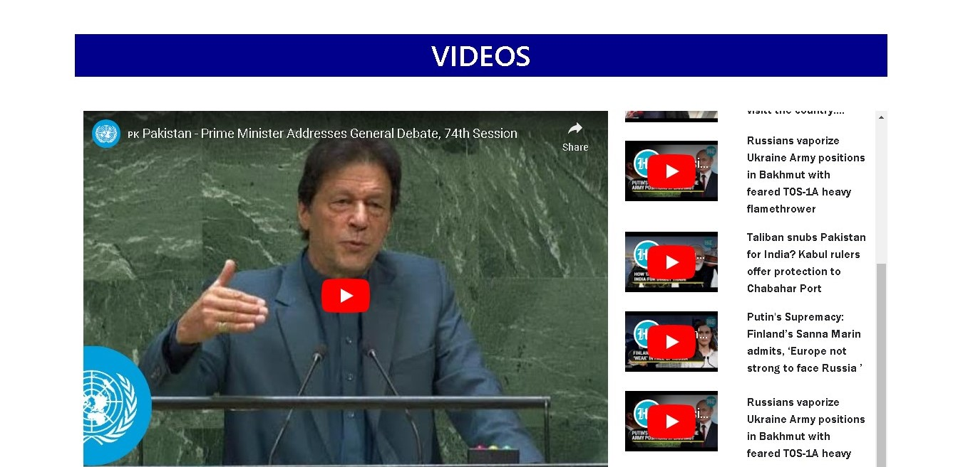

**3.** **Sport Page**

This is the Sport Page.

* From this page,users take update about latest sports events.





**4.** **Contact Page**

This is the Contact Page.

* In this page users can get in touch with us.
* They can leave their comment.

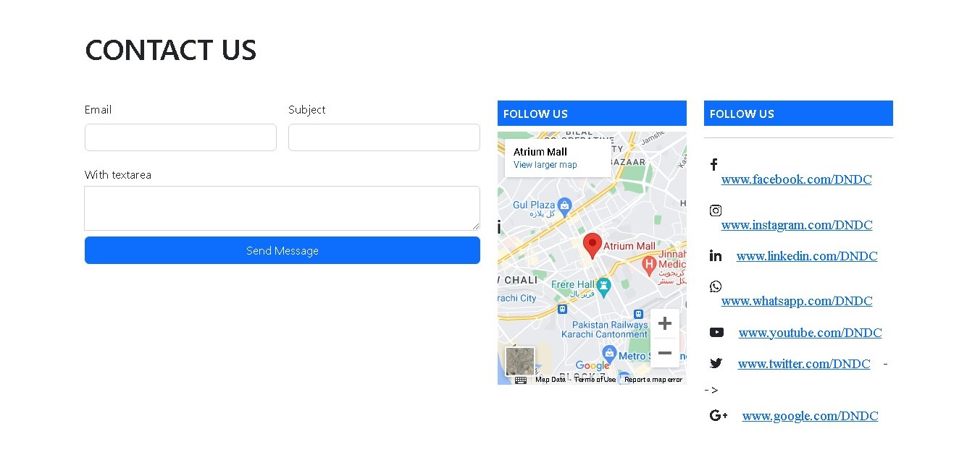

**5.** **About Page**

This is the About Us Page.

* This page has some Information about our news.

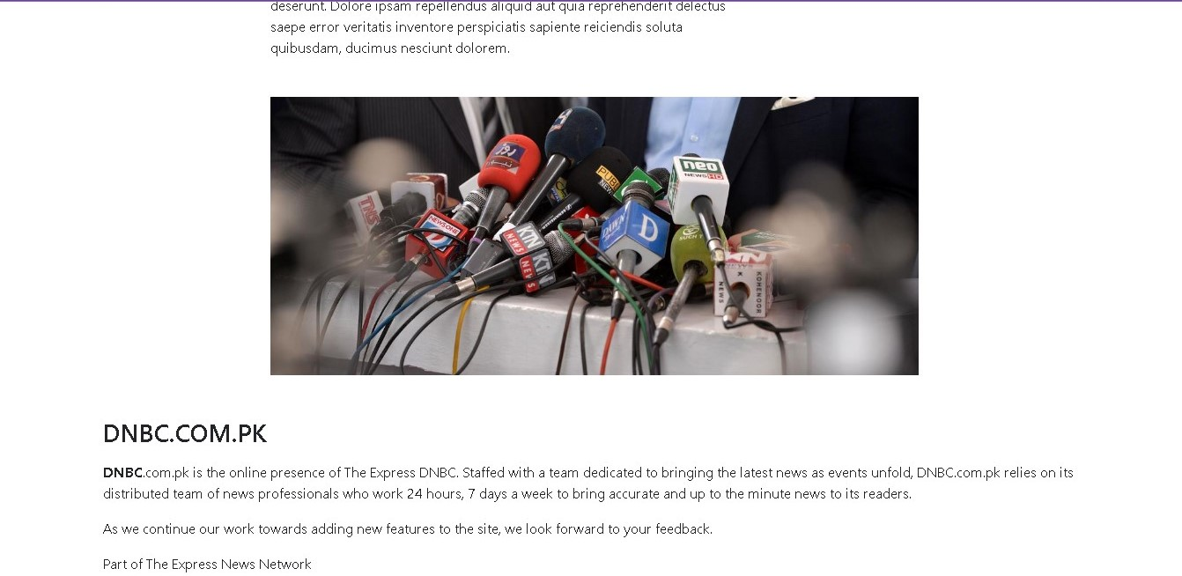

**6.** **Business**

* In this page first user can know more informative news about the latest market news and what's going on all over the world .
* Our News and reporting website is very informative for you and it gives a lot of news about business.

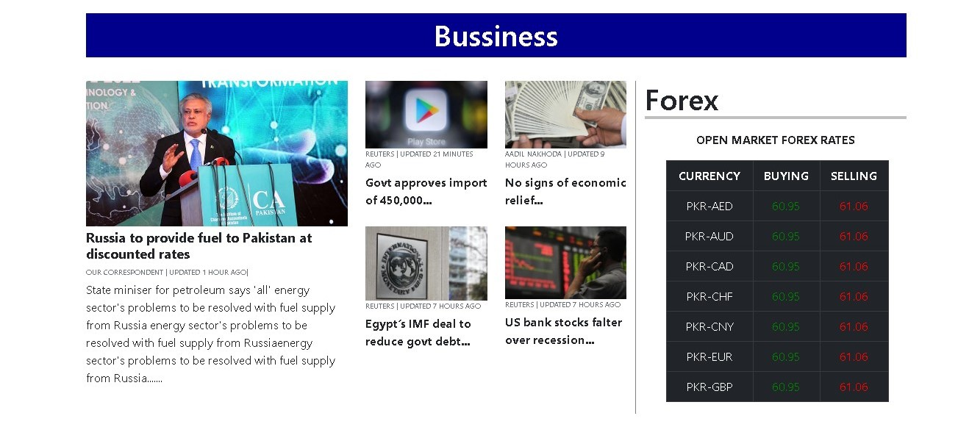

**6.** **Todays in World**

* In this page first user can know about the trending news and trending cities all over the world ..



**7. Bottom Layout**

This is the Bottom of the page.

* It has some Links like Rewards , Contact Page and Our Specialities.
* It has some Popular Recipes link as well as some Official Pages links

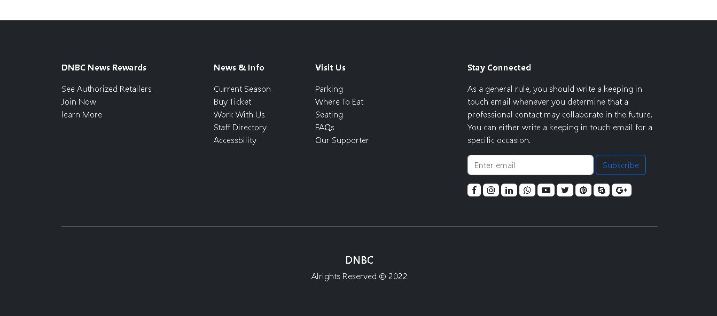

**Thank You For Reading The Documentation.**